Safeguarding Procedures
The following procedures provide detailed guidance for implementing the MRF Safeguarding policy across the organisation.

Planning for implementation of the Safeguarding Policy
Meningitis Research Foundation (MRF) will develop and maintain an implementation plan for the Safeguarding Policy to ensure effective implementation across the organisation and with partners and contractors, where applicable. This plan will form the basis of safeguarding monitoring by the Board of Trustees.
MRF recognises that safeguarding is the responsibility of everyone in the organisation and that, regardless of individual roles, we all have obligations under the policy and a contribution to make in creating safe environments. Managers have a particular responsibility to promote the importance of safeguarding and ensure the policy and associated safeguarding measures are in place and working effectively.
All individuals will be responsible for ensuring that the principles, procedures and good practices outlined in the policy are incorporated into their work. Where appropriate, revisions to other business area policies and procedures, e.g. recruitment and selection policies, to include child safeguarding will be undertaken and this will be overseen by the senior manager responsible for each department.
MRF has also established a designated Safeguarding Officer, Support and Membership Manager – Cat Shehu, whose role is to oversee implementation of the policy via training, advice, guidance and input locally. The Safeguarding Officer exists as a resource to support managers and other colleagues in achieving full and effective implementation of the policy.
Prevention
Human resources and recruitment procedures
All staff will be recruited to clear job descriptions that include a statement on the role’s responsibilities to meet the requirements of the MRF Safeguarding Policy.
All staff will be appointed in line with MRF’s Recruitment and Selection Process Policy to ensure that all necessary checks are carried out. Pre-selection checks for staff whose work brings them into contact with children and their data must include:
- Completion of an application form, including a self-disclosure about criminal records
- Interviews that include questions about suitability to work with children and/or interviewee data explored for relevant positions
- Receipt of two references from previous employers or education providers in accordance with MRF’s recruitment and selection procedures. Where references are verbal the appointing manager must document the verbal reference with a signature (or e-signature) and date
- Verification of original qualifications where necessary and appropriate (e.g. technical qualifications or membership of regulatory body)
- Verification of identity
- Consent to obtain information for enhanced vetting through relevant UK or Irish bodies to check for convictions for criminal offences against children in accordance with current legislation

Offers will be provisional until the above checks have been completed with no concerns identified about suitability to work with children or vulnerable adults. All successful applicants will be provided with a copy of the Safeguarding Policy and the Code of Conduct which they will be required to sign to confirm understanding and adherence.
Screening by the Disclosure and Barring Service (England & Wales), Access NI (Northern Ireland), Garda Vetting (Ireland) or Protecting Vulnerable Groups, PVG (Scotland) will be undertaken on all staff who regularly come into contact with children and/or vulnerable adults whilst representing MRF, where individuals are eligible to obtain such checks. The level of contact with children or vulnerable adults for a position should be decided by the recruiting manager and relevant human resources staff, at the time the job description/contract is agreed and prior to obtaining approval to recruit/contract. A register of posts which are subject to enhanced checks will be maintained by the Director of Finance and Administration, who will ensure that renewals are made when required.
If a staff member raises a legitimate concern about suspected abuse that proves to be unfounded, no action will be taken against that staff member. Any staff member making false or malicious accusations of abuse will face disciplinary action. See the MRF Whistle-Blowers Policy on page 33 of the Employee Handbook.
Referencing and ID checks will be undertaken for office based volunteers prior to starting at MRF.
Relevant policies and procedures will be updated to reflect safeguarding considerations, including the Recruitment and Selection Process Policy.
Training
MRF notes that, in order for the Safeguarding Policy to be well understood and effectively implemented, it is essential that there are high levels of awareness regarding the policy and that staff and others are clear, confident and competent in putting the policy into practice.
All staff, office based volunteers and associates (including befrienders and ambassadors) will be required to sign the MRF-Code of Conduct upon joining the organisation, or at the point of engagement. This will be accompanied by a briefing on the Safeguarding Policy and the Code of Conduct and what these mean for staff conduct.
Staff and office-based volunteers with a medium- to long-term engagement with MRF (over 3 months) will need to be inducted more fully on the Safeguarding Policy. For staff, this induction will take the form of a half-day workshop which will enable participants to explore more fully what is meant by child abuse, their obligations under the Safeguarding Policy, what to do if they have concerns and how to overcome challenges with reporting. Volunteers and associates (including befrienders and ambassadors) will be briefed on the policy and procedures and, where applicable, these will be incorporated into their regular meeting/training days. Specific roles will be risk assessed to consider further training requirements.
Staff who have specific responsibilities, e.g. Safeguarding Officer, managers responsible for risk assessing business areas, or those responsible for assessing and engaging partners, will have additional training on how to perform their roles fully. MRF will develop and maintain a staff training plan for safeguarding which is regularly reviewed as part of the implementation plan.
MRF will ensure access to regular training updates and refresher courses to ensure that the policy continues to be embedded and that staff are made aware of changes and developments to the policy and its implementation.
Risk assessment
All business areas of MRF which have contact with, or impact on, children or vulnerable adults should be subject to a risk assessment so that potential risks can be identified and mitigated. Safeguarding risks will be included in the organisational risk register and in project/event risk assessments. Risks will be reviewed by the relevant personnel on a quarterly basis to ensure that actions are being taken, and the risk registers are updated where necessary, with regular reporting to the MRF senior management team.
A risk assessment must be completed in advance of:
- Recruitment to a new or existing post which involves working with children and/or vulnerable adults;
- The commencement of new MRF-owned projects, activities or events involving or potentially involving children and/or vulnerable adults;
- Changes being made to MRF-owned projects, activities or events involving or potentially involving children and/or vulnerable adults.
Risk assessments must be completed by a competent person (someone who understands the job, activity or event and is aware of the hazards) using the standard Risk Assessment Form All risk assessments are, to a degree, based on the views of the assessor; the assessment can be made less subjective by involving others in this process.
The purpose of the risk assessment is to enable the responsible person(s) to identify, mitigate and remove any potential risks relating to contact with children and/or vulnerable adults. This can also be a prompt to consider alternative working practices, such as minimising occasions where an individual is alone with a child or vulnerable adult and considering whether the activity could be supervised or observed by others.
Completed risk assessments should be retained whilst an activity, project or event is ongoing and for 3 years after it has ceased (or the risk assessment has been superseded). Where an activity is ongoing but unchanged, the risk assessment should be reviewed at least every 6 months to ensure that the measures put in place are still relevant and appropriate.
Designating key staff
- The Safeguarding Officer is responsible for monitoring our practice in relation to this policy and for managing any incidents or activities that arise. Formal reports can be lodged and safeguarding concerns can be discussed with the Safeguarding Officer. The current designated Safeguarding Officer is:

Contact | Cat Shehu
Email | cats@meningitis.org
Tel | 07577 580609

- The Safeguarding Officer reports directly to the Chief Executive on safeguarding issues, who is accountable to our Board of Trustees
- The Trustees of MRF have overall responsibility for safeguarding. A Trustee will be nominated as safeguarding Trustee for the Board, who is responsible for any safeguarding issues relating to the Board itself and any necessary reporting of investigations and incidents to the appropriate authorities. The current nominated Trustee is: Sarah Jeffery.

Reporting and responding to concerns, complaints, allegations, suspicions, and incidents
MRF is committed to responding to all reports or indications, including rumours, that suggest a child or vulnerable adult may have been harmed or may be at risk of harm. Any allegations of abuse made against anyone working for MRF in any capacity will be thoroughly investigated as will any alleged breach of the Safeguarding Policy or the Code of Conduct.
MRF operates a Whistle Blowing Policy. We assure all staff, partners and associates that we will fully support and protect anyone who, in good faith, reports a protection concern. All reports will be treated as confidential but it must be appreciated that, in some situations, the investigation or disciplinary processes may not be concluded unless the source of the information and a statement by the individual is produced as part of the evidence.
Preparing for receiving reports
A key element in making appropriate and effective responses to safeguarding and protection concerns is having a clear picture of the local context so that responses are made in line with legal, statutory and social welfare considerations. The Safeguarding Officer is responsible for completing mapping exercises which identify important information such as the age of consent, key legal provisions that exist for the protection of children and vulnerable adults, and the agencies that have responsibility for investigating child abuse issues and meeting the protection and health needs of child victims, as well as deciding on what steps must be taken when concerns arise about a child. This should include clarifying which reports should be shared to relevant local agencies in the UK and Ireland and developing a list of contacts/organisations that can provide support if concerns arise. Further information relating to UK and Irish requirements can be found at https://www.gov.uk/report-child-abuse and https://www.tusla.ie/children-first/individuals-working-with-children-and-young-people/how-do-i-report-a-concern-about-a-child/
Reporting concerns

Safeguarding concerns can be reported confidentially by email, telephone or in-person and should be submitted to the Safeguarding Officer or local manager within 24 hours of the incident or concern arising whenever possible. Reports can also be formally received by the Chief Executive or nominated Trustee.
Through accountability processes, beneficiaries will be made aware of their right to report safeguarding concerns and the routes through which they can do so. Responsibility for ensuring this is undertaken sits with the senior managers of each department.
Please see Appendix B for reporting procedure flowcharts. All reports and concerns should be recorded using the report form Appendix C.
Responding to reports

The person who receives the report will make immediate decisions regarding the need for urgent action (medical attention, protection). The person receiving the report will also be responsible for ensuring that all available information is gathered and recorded. Original notes should be signed and dated and kept in a secure place for an indefinite period. These are essential in helping Social Services or the Police decide what is best for the child/adult, and as evidence if necessary.
The person who receives the report should immediately inform the Chief Executive and Safeguarding Officer (unless involved) using the Reporting Form.
Case discussions involving relevant staff (e.g. safeguarding officer) will take place as soon as possible following receipt of a report, but no later than 24 hours after the event, to agree the appropriate process based on the nature and severity of the incident(s), referring to MRF’s Disciplinary Procedures on page 18 of the Employee Handbook, if the report relates to a member of staff. The initial response should be to ensure the safety and wellbeing of the person/people affected. Immediate protection measures (to be agreed with the Chief Executive and nominated Trustee) may also include the need for suspension without prejudice of the person that is the subject of concern.
The Safeguarding Officer, along with the Chief Executive, will be responsible for agreeing decisions on urgent referral to national authorities as in the set out in the mapping data. When appropriate, the Employee Assistance Programme (EAP) will be consulted for expert advice. The Police should be contacted where there is a concern about the possible abuse of a child and/or other possible criminal breaches. If the report involves an adult, the case may be referred to the local authorities if s/he agrees to a referral and if this does not represent a protection risk to anyone involved. It is the legal responsibility of the statutory protection agencies to find out if abuse has taken place; MRF recognises that it not our responsibility to decide whether abuse has taken place. If the concern involves a criminal matter MRF cannot investigate alongside police investigations.
The decision to investigate a concern will be made by the Chief Executive and nominated Trustee, in consultation with the Board of Trustees’ HR Sub-committee. Where an investigation is instigated, the entire Board of Trustees will be informed, with restricted details provided. Investigations will be led by the Bristol office and will be objective, transparent, and guided by external professional expertise and support as required.
Depending on the nature of the allegation, the subject of the investigation may be suspended (with pay) from their function pending the outcome of the investigation. Such suspension will be sanctioned by the Chief Executive or the nominated Trustee if the Chief Executive is somehow involved.
It is the right of any individual to make direct referrals to the statutory authorities. If you feel that your manager or the Safeguarding Officer has not responded appropriately to the concern/incident raised, then you may contact another senior manager in the organisation. If an appropriate response is still not provided you may report your concerns to the protection agencies directly.
All reports and other documentation relating to protection concerns will be treated as confidential and stored securely by the Safeguarding Officer whether kept physically or electronically (in the restricted Safeguarding folder only: F:\Master - Admin\HR\Safeguarding). Access to, and sharing of, documents will be strictly on a ‘need to know’ basis. The use of names and identities of the people involved will be kept to the absolute minimum required for proper investigation and addressing of the complaint or report.
MRF’s duty of care to promote the welfare and protect the safety of children or vulnerable adults we are in contact with will always be at the forefront of decisions made about sharing personal data and information, as set out in GDPR policies and procedures.
Reporting perceived risks

Where there is a perceived concern that a member, supporter or associate of MRF may be vulnerable to harm, or at risk of causing harm in the future (when there is no incident to report) this should be confidentially reported to the Safeguarding Officer who will complete the Reporting Form. The local manager, along with the Chief Executive, will decide on the follow-up actions. This will include informing relevant staff members of the concern and deciding on what control measures are implemented, depending on the nature and severity of the concern.
Control measures may include suspending the individual from activities on a permanent or temporary basis, amending contact preferences on a permanent or temporary basis and providing additional support. Expert advice can be sought from the Employee Assistance Programme (EAP) or other independent sources.
The local manager will decide what information can be shared and recorded on the MRF database, Donorflex, clearly indicating in the individual’s record where necessary to contact the relevant local manager before communicating or taking further action concerning the individual. Confidential information relating to the nature of the concern should not be recorded in Donorflex. Any control measures put in place will be monitored by the local manager and fed back to the Safeguarding Officer. If the local manager responsible for decision making should leave MRF, it is important that this duty is appropriately transferred to another staff member during a hand over before leaving.
An anonymised report will be provided to the Trustees at the next scheduled Board meeting.
Disclosure by a child
If a child makes a disclosure alleging abuse, you should stay calm, listen carefully, be reassuring and explain that you will have to share the information with others. You must NOT promise to keep the disclosure a secret. Any disclosure must be immediately reported and recorded in writing as soon as possible. It is not your responsibility to carry out an investigation.
Accountability
- The Chief Executive, or the nominated Trustee if the Chief Executive is somehow involved, will ensure appropriate follow-up and notification of relevant external bodies is made.
- There is a requirement to report on matters of “risk to charity’s beneficiaries” see Charity Commission - Raising Concerns.
- Trustees have the primary role in dealing with issues and need to be clear about their responsibilities. They are required to report to the Charity Commission “incidents of a serious nature” – see Charity Commission - Reporting Serious Incidents
- MRF will sever all relations with any staff proven to have committed abuse of a child or vulnerable adult and will support in full any related criminal prosecution.

Partners & Associates
MRF projects may be implemented through partners that are independent organisations. Before deciding whether to enter a partnership with another organisation, MRF will look carefully at whether that organisation has effective policies in place to provide strong safeguards for children and vulnerable adults in its activities. Please see the partner assessment form considerations in Appendix A which should be incorporated by departments into relevant partner assessment tools. If these safeguards exist, MRF may proceed to develop a partnership agreement. MRF accepts that formal policies may not be in place - if the organisation demonstrates a willingness to develop safeguarding policies and procedures, we may still consider partnership and will monitor the progress of the development and implementation of policies.
Partner organisations are required to sign a commitment to the MRF Safeguarding Policy which is appended to the partnership level agreement or Memorandum of Understanding (MoU). In the selection, management and monitoring of partners, MRF will address safeguarding requirements to support partners to comply with the Safeguarding Policy. MRF will provide support to build the safeguarding capacity of partners, if deemed necessary, relevant to current capacity, the project design and level of risk.
External associates working with children and/or vulnerable adults at MRF events will be required to confirm enhanced screening status in writing before the event.
The partnership agreement or MoU will include a clause with the following points relating to safeguarding:
- Employees of partner organisations are encouraged to report any observed or suspected violations of the Safeguarding Policy, whether by MRF employees, related personnel or representatives of partner organisations
- To report such violations, partner employees are encouraged to address their concerns to MRF’s Safeguarding Officer, contact details of whom will be shared upon entering into an official agreement with MRF
- If the MRF Safeguarding Officer, for whatever reason is not found to be an appropriate channel for the complaint, partner staff may approach MRF’s Chief Executive or nominated Trustee
- The Safeguarding Officer will complete a Reporting Form
- Where a partner is responding to a concern that a child or vulnerable adult is at risk of, or experiencing harm within an MRF-funded project or otherwise, MRF should be informed as soon as possible, and no later than 1 day of the partner becoming aware of the concern
- The partner will investigate the concern, support the child or vulnerable adult and alert local authorities according to their organisational procedure and national legislation
- The partner will inform MRF of the outcome of any investigation within 1 week of becoming aware of the concern. If the investigation is ongoing, the partner will inform MRF of the progress of the investigation and agree further communications or action required
- MRF reserves the right to undertake its own investigation if it determines that the information provided by the partner is unsatisfactory or the investigation has not been carried out effectively:

- MRF will take responsibility for investigating the concern, as well as working with the partner to support the child and alert local authorities according to organisational procedure and national legislation
- MRF will inform the partner of the outcome of any investigation within two weeks of becoming aware of the concern. If the investigation is ongoing, MRF will inform the partner of the progress of the investigation and agree further communications and actions
- MRF reserves the right to terminate partnership agreements where it has reason to believe that safeguarding standards put children or vulnerable adults at risk of harm

Appendix A - Partner Risk Assessment Considerations

To be incorporated by departments into relevant partner assessment tools.
Area of Safeguarding | Standards for Organisations | In Place | Partially in place | Not in place | Actions Agreed
Procedures to keep children & vulnerable adults safe | The organisation has a written Safeguarding Statement (that includes a Code of Conduct) that all staff must sign and follow.
 | The consequences of breaching the Code of Conduct are clear and linked to organisational disciplinary procedures.
 | There are clear, well-publicised reporting procedures in place that allow staff, children and families to raise concerns, confidentially if necessary, about poor practice, unacceptable behaviour or actual/potential abuse by other staff or contractors and that provide step-by-step guidance on what action to take.
Preventing harm to children & vulnerable adults | There are procedures or agreed ways of recruiting staff and partners that include assessing their suitability to work with children and vulnerable adults, and that where possible, police and reference checks are undertaken.
 | Projects/Programmes have been risk assessed and the necessary actions identified/implemented to minimise risks of harm to children and vulnerable adults.
 | Measures are in place to operate good practices for obtaining and publishing images and information on children and vulnerable adults.
Implementation and Training | All members of staff and partners have training on safeguarding, which includes an introduction to the organisation’s Safeguarding Statement and Code of Conduct.
Information and Communication | Children and families are made aware of their right to be safe from exploitation and abuse at the hands of staff and associates and how to make complaints, including via an accessible mechanism, should any issues or incidents arise.
 | Everyone in the organisation is informed of which named staff member/s have special responsibilities for safeguarding and how to contact them.
Monitoring and Review | The implementation of organisational safeguarding measures is subject to regular monitoring and review to ensure adequate steps have been taken and the effectiveness of these measures.
 | All concerns, incidents or allegations of abuse and complaints are taken seriously, responded to appropriately, recorded, followed up and monitored.
Partnership Responsibilities | Contractors/Consultants working with children and vulnerable adults must meet the above standards and ensure that their sub-contractors also have in place measures that mean they are in compliance with the standards.

Appendix B - Reporting Procedure flowcharts

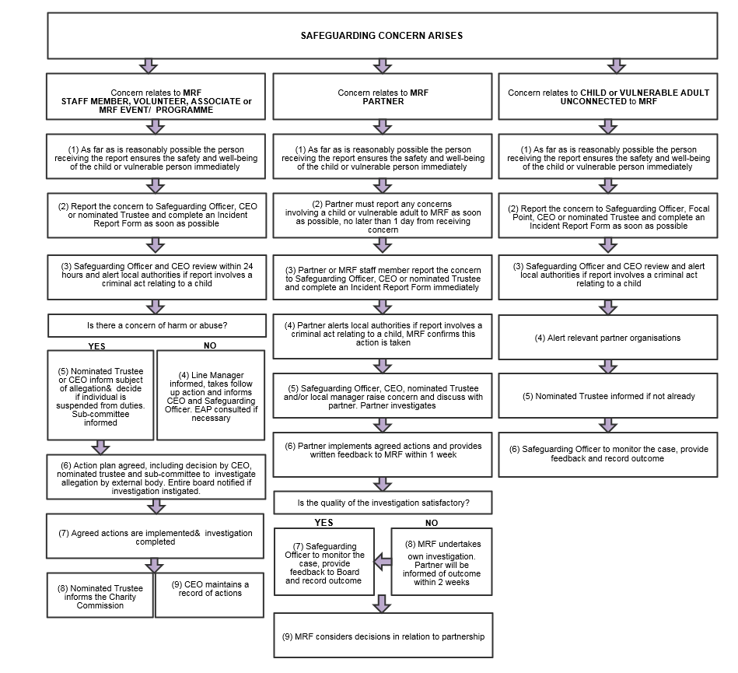

Appendix C - Reporting Form
If you have safeguarding concerns or wish to report any breach of MRF’s Code of Conduct, please complete this form to the best of your knowledge.
- Please note that safeguarding concerns must be reported directly to the Safeguarding Officer as soon as possible (at least within the same or next working day).
- Depending on the urgency, you may wish to complete this form before contacting the Safeguarding Officer or you may wish to complete the report afterwards.
- For confidentiality reasons, the report should be written and signed solely by you. It should be sent only to the Safeguarding Officer. It will be held in a safe and secure place and treated in the strictest confidence.

1. About You
Your name:
Connection with MRF: (please state if you are a staff member, volunteer, beneficiary (including members), partner, fundraiser etc.)

Workplace:
Incident/concern about me ☐
Reporting on behalf of someone else ☐ If so please give details of how you learnt of this incident/concern (e.g. personal observation, suspicion, disclosed by person affected, disclosed by someone else) and in what capacity have you had contact with person affected:

Reporting a perceived risk ☐
Details of how you became aware of the incident/concern/perceived risk:

2. About the person(s) affected (if this report does not relate to personal experience)
Name:
Please state how this person is connected with MRF:
Is this person a child or deemed to be vulnerable? If yes please give details of age, specific vulnerability and any other relevant information:

If the person is a child or vulnerable person please give details of parents/carer(s):
Name:
Tel:
Is the affected person(s) aware that the incident/concern is being reported?

3. About your concern
If the concern was shared by someone else, please state who and their relationship to the person(s) affected:

If the concern is regarding an alleged perpetrator pleased provide-
Name:
Capacity known to you and/or MRF:

Date:
Time:
Location:

Nature of the concern (please give details)

Your personal observations (visible injuries, emotional state, etc.) [N.B. Make a clear distinction between what is fact and what is opinion or hearsay]

Exactly what the person affected or other source said to you (if relevant) and how you responded to him or her: [Record actual details]

In what capacity is the alleged perpetrator known to you and/or MRF?

Any other information not previously covered: (If necessary, include a timeline of events.)

Were there any other people/children involved in the alleged incident?

Are any other people/children at risk of harm?

Action taken by you:

Signed: Date:
4. Response actions taken (to be completed by the Safeguarding Officer)
Recommended Actions (including timeframes) | Who else needs to be informed (include relevant body of concern and contact person) | Action taken by | Date

5. Follow up and closure (to be completed by the Safeguarding Officer)
Actions (including timeframes) | Who else needs to be informed (include relevant body of concern and contact person) | Action taken by | Date

The policy defines children as those under 18 and prohibits any sexual relationships or activities with children, but it is important to know the local age of consent in order to determine whether or not a reported concern represents a criminal matter

